

**School of Information Technology**

Course : Diploma in Business Informatics

Subject : ITP282 - Enterprise Application Development & Project

AY / Sem : 2018 S2

**Lab 1a: Getting Started with Microsoft Visual Studio Web Application Development using C#.**

**OBJECTIVES:**

At the end of this **Practical**, the students should be able to:

1. Use the Visual Studio to develop a simple web application
2. Use the Integrated Development Environment (IDE) features for web application development

# Introduction

Microsoft Visual Studio is a complete set of development tools for building ASP.NET Web applications, XML Web services, desktop applications, and mobile applications. Visual Basic, Visual C++, Visual Basic, and Visual J# all use the same integrated development environment (IDE), which allows them to share tools and facilitates in the creation of mixed-language solutions.

# Exercise 1

In this exercise, we will create a simple web application.

To build an ASP.NET web application, we need to create a new web site in Visual Studio.

## Build your Application

1. From the Windows Start menu, open Microsoft Visual Studio 2015 (VS).
2. In VS, select File 🡺 New 🡺 Web Site….

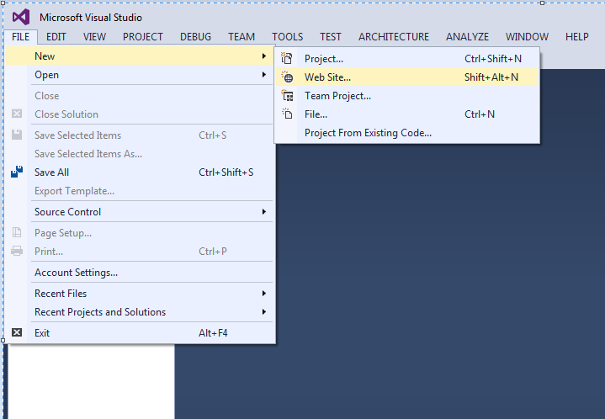

1. In the New Web Site dialog (see Figure 1):
   1. Under Installed - Templates, Select C#.
   2. Then select ASP.NET Web Forms Site.
   3. For Web location, make sure File System is selected and browse to any folder on your PC (eg: **C:\Users\<adminNo>\Desktop\**). Finally, make sure that you end the path with '**ITP282_Lab1a**'.

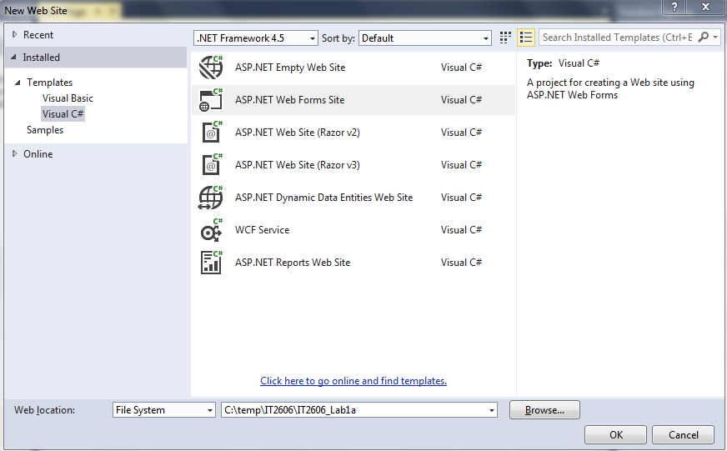

Figure 1: New Web Site creation dialog box

You have just created an ASP.NET Web site. By default, VS creates a 'home' page as 'Default.aspx'. This means that when you deploy your web application onto IIS Web Server, this will be the starting page of your web application.

You should be seeing something similar to Figure 2. What you see there is the Source view of Default.apsx. The code you see is ASP code. Notice that it looks a lot like HTML. In fact, you can mix HTML with ASP. We will explore more about ASP code and ASPX files in the next practical.

In the Solution Explorer you will see the files and folders that make up your ASP.NET web site. We will learn more about the files in the following lessons. For now, just notice that Default.aspx is listed there too.

On the left, there is a Toolbox tab. Click on it to see its contents. It may take a few minutes to show. These are the controls that we can use on the .aspx page.

The Properties panel allows us to set the various properties of the document and controls. The contents will change depending on what you select on the page.

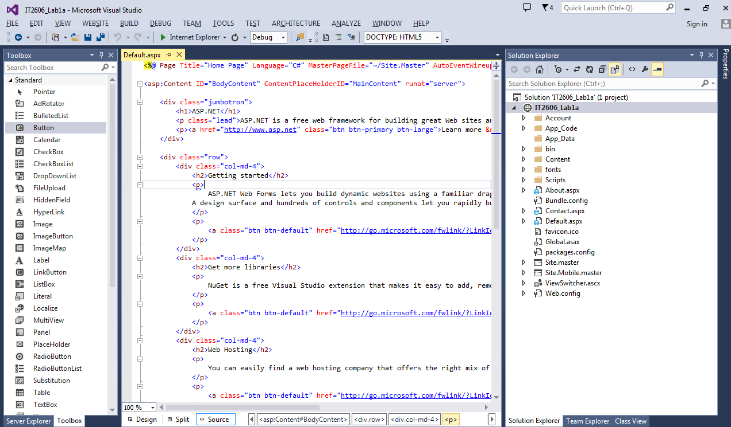

Figure 2a: Source View

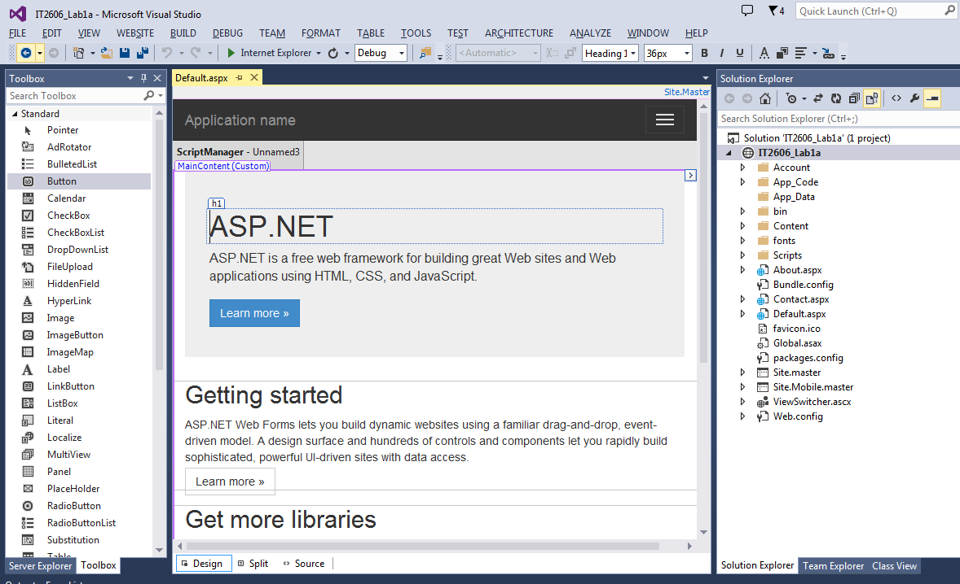

Figure 2b: Design View

Now click Design in the View controls. You will now see Default.aspx as it is meant to be seen. However, to allow us to manipulate the page and controls, there are some slight differences. The best way to check what your .aspx web page will look like is to test it in a web browser. Before that, click on Split in the View controls and see what it looks like.

## Testing the Web Site

Now let's view Default.aspx in a web browser.

Right click Default.aspx in the Solution Explorer and select View in Browser (see Figure 3).

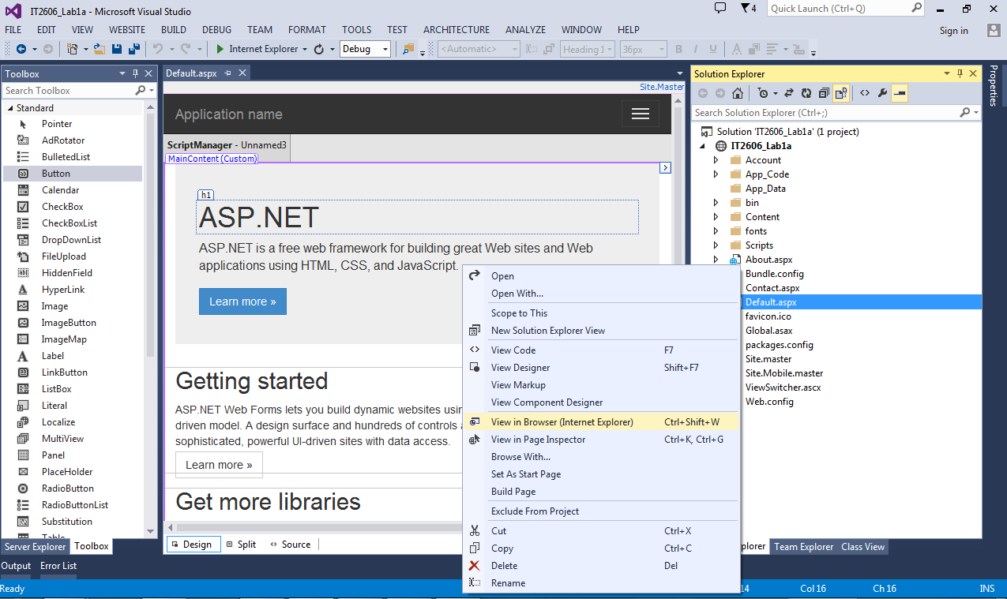

Figure 3: Testing the newly Created Web Site

VS will now perform the following steps:

1. Compile the web site, if necessary.
2. Start a virtual web server.
3. Open Default.aspx in the default web browser.

You should something like Figure 4.

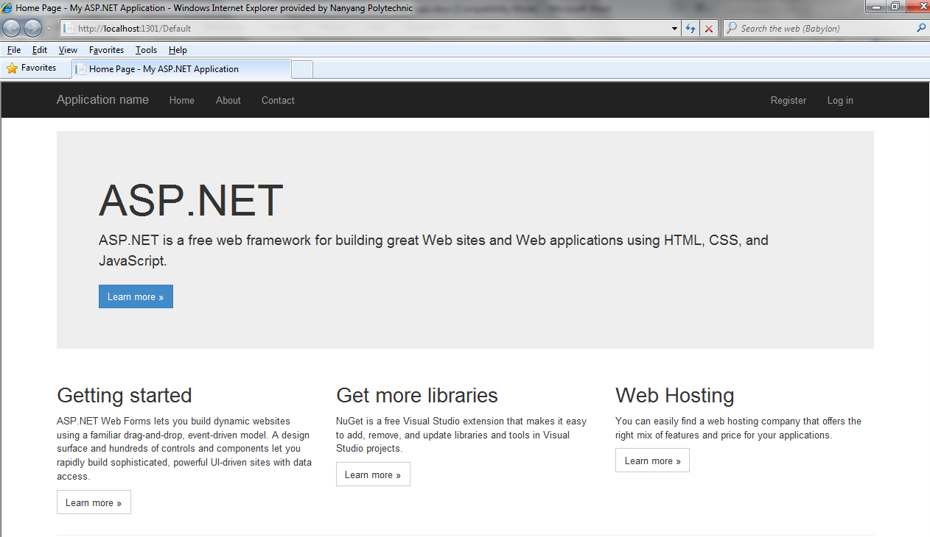

Figure 4: Web Site displayed in Browser

Close the browser and return to VS.

Next, we will learn how to debug the web site.

## 

## Starting Debugging for the Web Site

1. From the menu bar, select Debug 🡺 Start Debugging.
2. The first time you debug any ASP.NET web site in VS, a “Debugging Not Enabled” dialog may be displayed. In order to debug the web site we need to enable debugging. Select Modify the Web.config file… and click the OK button. VS will add the necessary settings to the Web.config file.  
   You will not be asked this question again for this web site.
3. VS will now perform the steps as before and open the page in IE. For now, there is nothing to debug, so just remember how to start debugging. In later lessons, we will learn how to debug an ASP.NET website.
4. To stop debugging, return to VS and select Debug 🡺 Stop Debugging. If you close the page on IE, VS will usually stop debugging automatically.

# Closing and Opening Web Sites

1. To close the Web Site, select File 🡺 Close Solution.

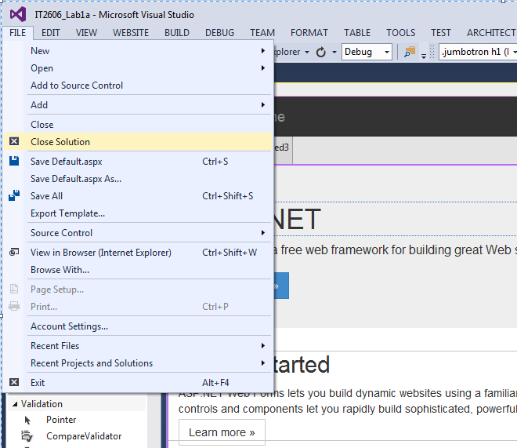

1. To open the same Web Site again, go to File 🡺 Recent Projects and Solutions and select the Web Site.

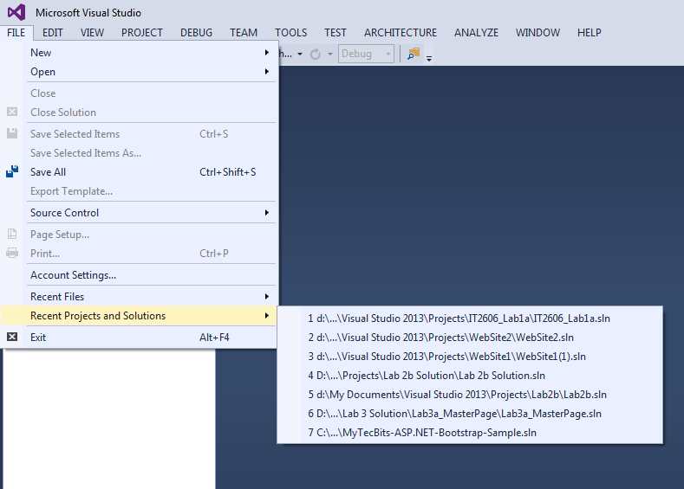

1. Close the Web Site again.
2. Sometimes, you need to copy the Web Site from one PC to another. In that situation, you will not be able to find it in Recent Projects and Solutions. To open a Web Site in that situation, do the following:
   1. Select File 🡺 Open 🡺 Web Site….

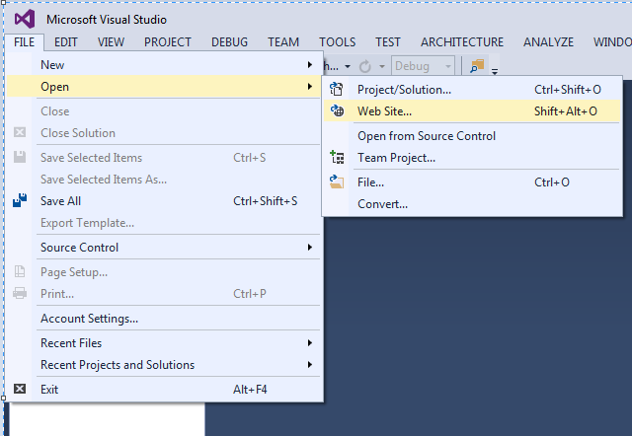

Figure 6: Reopen the Newly Created Web Site

* 1. In the Open Web Site dialog, browse to and select the folder that contains the web site newly created (**ITP282_Lab1a**) and click the Open button.

***========== End ==========***